Curriculum vitae - Károly Lázár

Prof. Habil., DSc., PhD - scientific advisor

Centre of Energy Research,
Hungarian Academy of Sciences
e-mail: lazar.karoly@energia.mta.hu,
tel: +36-1-392-2537, fax: +36-1-392-2533
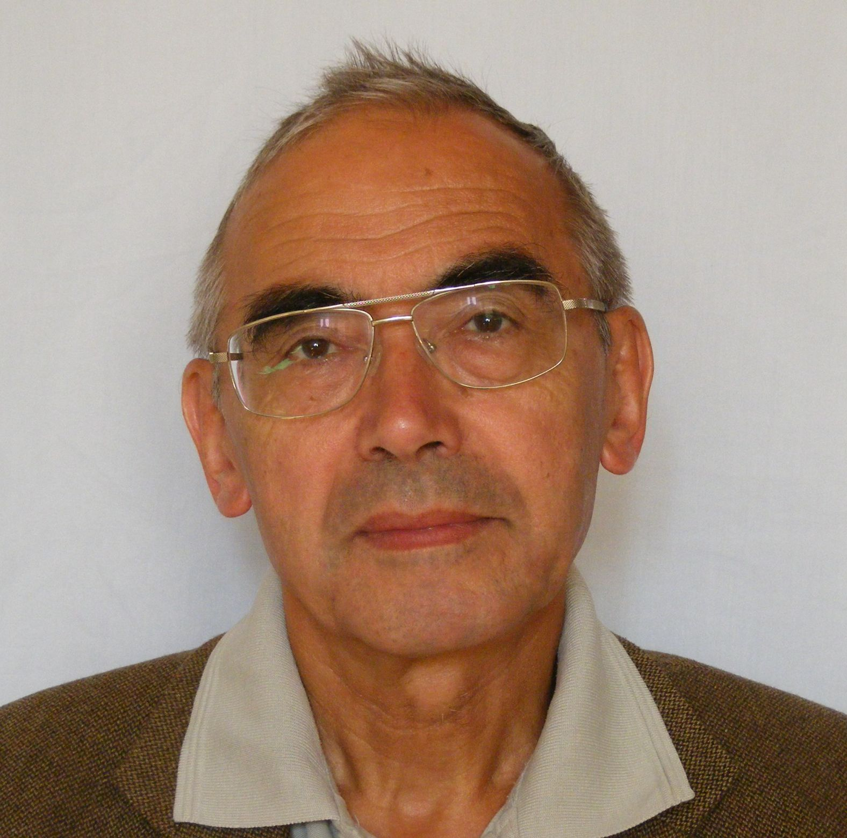

Date and place of birth: 16. 06. 1948, Budapest, Hungary
EDUCATION, DEGREES:
2001, Prof. Habil., University of Technology and Economy, Budapest,
1992, Doctor of Sciences, Hungarian Academy of Sciences,
1984, Candidate of Science, (Ph. D.) Hungarian Academy of Sciences,
1973, PhD in Chemistry, Eötvös Loránd University, Budapest,
1971, MSc. in Chemisty, Eötvös Loránd University, Budapest

EXPERIENCES, POSITIONS

2012 - Head, Nuclear Chemistry - Mössbauer spectroscopy team, Research Centre for Energy , Hungarian Academy of Sciences,
1999 - 2011 Deputy Director of the Institute of Isotopes, Hungarian Academy of Sciences,
2009 - 2011 Head of the Department of Application of Radioisotopes and the Mössbauer Laboratory
1993 - 2008 - Head of the Department of Catalysis and Tracer Studies and the Mössbauer Laboratory
Performing mostly various in situ Mössbauer studies. Studying migration of radioisotopes in geological samples (in relation with perspective disposal of high level nuclear waste).
1987-1992 Variety of in situ Mössbauer studies, Research fellow, Institute of Isotopes,
1985-1987 In situ ¹¹⁹Sn Mössbauer spectroscopy studies on SnIr bimetallic catalysts, as a fellow at the Institut de Recherches sur la Catalyse, CNRS, Villeurbanne, France
1982-1984 Magnetic and Mössbauer spectroscopic study of layered and two-dimensional complexes (as a post-doc at the Department of Chemistry, Northeastern University, Boston, MA, USA)
1979-1982 Start of studying catalysts by in-situ Mössbauer measurements: studies of carbide formation of iron in CO + H₂ reaction, and study of bimetallic (PdFe, CoFe, RhFe. etc.) supported catalysts. (Institute of Isotopes, research associate).
1971-1979 High-temperature metal-gas reactions, carburization of iron, nickel and alloys, studied by resistivity relaxation and thermopower measurements (Research Associate at the Central Research Institute for Physics, Budapest)
1970-1971 Basics of Mössbauer spectroscopy, studies of frozen solutions and iron precipitates. (Graduate student at the Eötvös University, Budapest)

PROJECTS
International – multilateral:
· Project coordinator : PHARE ACCORD H-9112-0338 (1993-1996, Novel methods for the preparation of nanostructured systems: their characterization and evaluation as heterogeneous catalysts , Budget: 70,000 ECU)
· Participant: COST CIPE CT 92 6107: (1995- 1998, Non-conventional preparation of novel uniform zeolite and supported catalysts).
· Team coordinator: IAEA CRP (1995 – 2000, Extrapolation of short term observations to time periods relevant to the isolation of long lived radioactive waste)
· Team coordinator in the FUNMIG EU FP6 - 516514 integrated project (Fundamental processes of radionuclide migration, 2005 - 2008),
· Team coordinator in the ReCosy EU FP7 – 212287 collaboratory project ( Redox Phenomena Controlling Systems, 2008 - 2012)
International - bilateral (Hungarian coordinator)
· 1998-2000, CAV – HAS (J. Heyrovsky Institute – Location of iron in molecular sieve matrices),
· 2000-2001, CNRS – HAS (with LACCO UMR C6503 at Poitiers University, Study of Ir base catalysts with different crystallite size of different preparations),
· 2006-2009 Cooperation in Science and Technology (with Slovenia, topic: Characterization of iron modified nanoporous silicates)
National grants - coordinator
· 1993-1995 (Preparation and stabilization of ultradisperseous metallic particles - OTKA T07364),
· 1996-1999 (Synthesis and study of nanostructured heterogeneous catalytic centres - OTKA T021131)
· 2000-2003 (Study of change in oxidation states on framework substituted ions in zeolites, OTKA T32249)
· 2007-2010 (Synthesis and characterisation of micro/mesoporous ferrisilicate composites, OTKA K68414)
· 2010-2013 (Extension of the in beam Mössbauer facility for low temperature measurements, OTKA K81863)

MEMBERSHIPS
2000-2006 (IBAME, International Board on the Applications of the Mössbauer Effect),
2003- Mössbauer Century Club
National:
1995 – 1999, Expert's Committee for Chemistry I., Board for Ranks in Science, Hungarian
Academy of Sciences
1996 – 2000, Council for Ethics of Science, Hungarian Academy of Sciences
1998 – , Hungarian Zeolite Association
1999 –, Catalysis Club of Hungary
2000 - ,Committee for Radiochemistry, Hungarian Academy of Sciences
2010 – 2016 Elected representative to the General Assembly of the Hungarian Academy of
Sciences

CONFERENCE ORGANISATIONS
Organising committee
· 1989, ICAME (International Conference on the Applications of the Mössbauer Effect, Budapest, Sept, 4 – 8, ) and Co-editor of the Proceedings (6 volumes of the Hyperfine Interactions, 2780 pages)
· 1999, 1st FEZA (Federation of European Zeolite Associations ) conference: Porous Materials in Environmentally Friendly Processes (Eger, Sept, 1 – 4)
Co-Chairman
· 2008, ISIAME (International Symposium on the Industrial Applications of the Mössbauer Effect, Budapest, 17 – 22 August)

PUBLICATIONS and their CITATIONS
Author and/or coauthor of over 210 publications
(see the on the personal home page: www.kfki.hu/~lazar ).
List of updated publications with corresponding citations in the official database of Hungarian scientific publications https://vm.mtmt.hu//www/index.php?AuthorID=10000751
Hirsch index: 28
Personal home page:
www.kfki.hu/~lazar

