**评分标准**

**所有打分均根据评分标准进行，并确保在70分以上。**

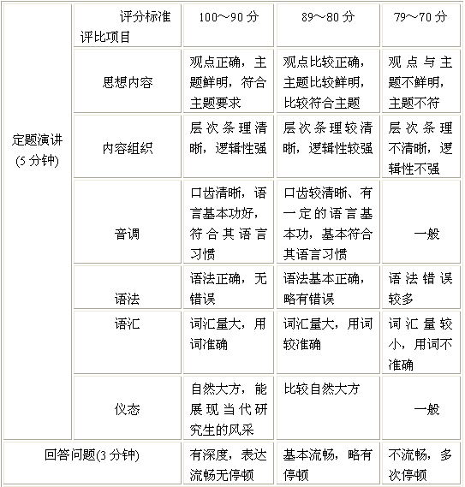

|  |  |  |  |  |
| --- | --- | --- | --- | --- |
| Speech Section (5 min) |  | 100～90 points | 89～80 points | 79～70 points |
| Subject | Coincident well with the theme, good point of view | Coincident with the theme, correct point of view | Unclear subject and point of view |
| Context | Clear and logical arrangement of the context | Nice | Common |
| Intonation | Good pronunciation and nice cadence of the expression. | Clear pronunciation and expression | Common |
| Syntax | Good sentence arrangement and nice grammar utilization | Correct sentence arrangement and grammar utilization | Common |
| Vocabulary | Large vocabulary and good word utilization | Correct word utilization | Common |
| Behavior | Good behavior and excellent presentation | Nice presentation | Common |
| Questioning Section  (3 min) | | Smart answers with quick response and fluent expression | Proper answers with normal expression | Unfluent answers and inconsecutive expression |

**All the constants’ final scores would be marked above 70 points according to the following criteria.**